HOLDUP AT THE ROYAL ARMY MUSEUM
or
How to destroy the State through its national heritage

HANDS OFF OUR NATIONAL HERITAGE !

WE PROTEST THE REMOVAL OF OUR HISTORICAL HERITAGE FROM BRUSSELS!

OUT OF RESPECT FOR TOURISM AND FOR THE COMMON HISTORY OF BELGIAN CITIZENS OF BRUSSELS, FLANDERS, AND WALLONIA:

WE DEMAND that THE collections of and at the Cinquantenaire be safeguarded and maintained, and furthermore demand that the historical rooms of the museum be given the status of a national heritage site of Brussels.

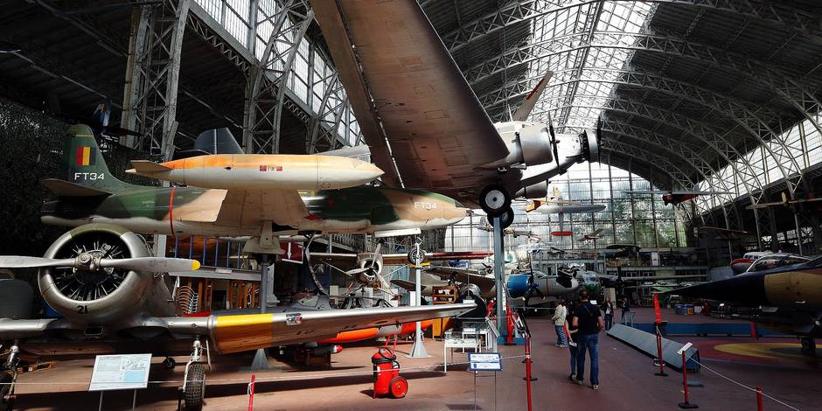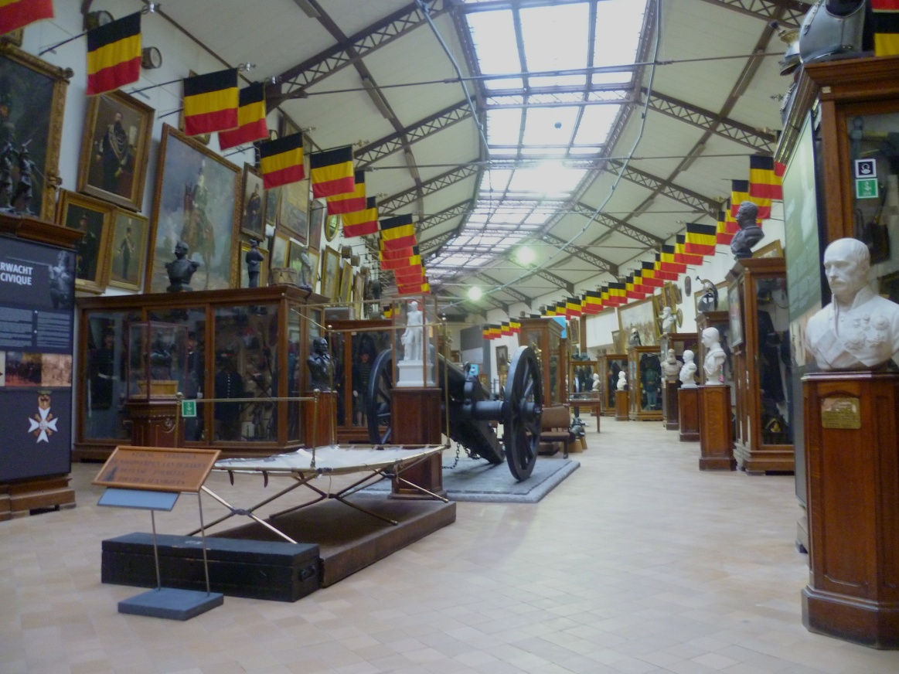

The historical and technological rooms of the Cinquantenaire Museum are being done away with. However, in fact they are genuine treasures of national history and of European museums, and they continue to fascinate visitors from all of the world.

For a number of years now the Museum, a showpiece of Brussels, has been targeted by the government for “mediocre management” and a “lack of initiative”. Nevertheless, the Museum has accumulated a cache of 2.5 million euros – subject to “legal” confiscation – while it has consistently broken records for number of visitors at the Cinquantenaire location (from 165,000 in 2011 to 260,000 in 2014).

It is true that for decades there has been a lack of will to renovate, while by their nature the collections are exhibited and indisputably recognized as setting a standard of quality worldwide – despite the dilapidated walls. A director must be appointed who will be aware of the needs and who will not be subservient to political interests.

The solution proposed by the Government:

To create a non-profit public-interest organization (type “B”), with three other small institutions of the Ministry of Defense, to be called the “War Heritage Institute”, which will not hold collections in its own right. These institutions could be merged, since the three entities represent an input of barely 15% of current staff.

This is what awaits all of the great museums of Brussels – to be swallowed up by politics with the help of the private sector.

Objectives announced by the Government:

To cut costs, and to break up the collections, which will be moved to touristic sites run by concessions or business partners, with the Royal Army Museum to become just one site among many. The institution known as the Royal Museum of the Armed Forces and Military History is fated to disappear at any moment.

In reality this means:

- Creating many new management positions: all chiefs and no Indians.
- Virtually no public funds set aside for renovation, but several million euros to be invested in useless offices.
- Handing over the task of management to a partner from the private sector, with no guarantee of value added with regard to heritage or science.
- Clearing out the collections of the Cinquantenaire which, while making areas available for exhibitions, would empty out the space under the pretext of renovating the exhibition rooms.
- All this is to happen to the benefit of certain specific sites managed by concession, namely, Braasschat and Léopoldsburg, the communes of Jan Jambon (N-VA) and Wouter Beke (President of the CDN-V), in order to create two museums with little effort just in time for local elections in 2018. And to the detriment of the Cinquantenaire Museum.

The process is already underway: 15,000 of the items are already in Flanders, and over 3,000 in Wallonia.

N.B.: According to the Topstukken Ordinance of 2004, any object, even if it is listed as part of the national heritage, can be held in Flanders permanently once it has been kept there for 4 years. A word to the wise…

The dismembering of the collections of the Royal Museum of the Armed Forces and Military History has begun, and it will escalate if we don’t react:

WE DEMAND that THE collections of and at the Cinquantenaire be safeguarded and maintained, and furthermore demand that the historical rooms of the museum be given the status of a national heritage site of Brussels.

Responsible Publisher: Comité Terveuren-Montgomery — http://tervueren-montgomery.eu
c/o Mme Corbisier — 99 Av. de Tervueren,, Bte 6, 1040 Brussels
Remember the environment – don’t litter!

PETITION TO DEMAND THAT the historical and technological rooms located at the Royal Museum of the Armed Forces and Military History at Parc du Cinquentenaire 3, 1000 Brussels, be given the status of a national heritage site.
Petition for classification in conformity with Art.222, al. 1er, 4° du COBAT

Please note: only persons over 18 years of age who are residents (Belgians and expatriates) of the Brussels Capital Region (postal codes 1000 to 1299) can sign. In order for the petition to be valid, all 5 columns must be filled out – the absence of even just one of the items will make the signature null and void. It is not necessary for the entire page to be filled with signatures: it’s better to send one valid signature than 100 that will be disqualified.
Please send any questions to: comite.tervueren@gmail.com

Please drop it off during business hours or send it to the following addresses:
Cinquantenaire: 26 av. de Tervueren, Box 3, 1040 Brussels (c/o Mr van der Straten)
Armée 99 av. de Tervueren, Box 6, 1040 Brussels (c/o Mme Corbisier)
Montgomery 148 av. de Tervueren, Box 14, 1150 Brussels (c/o Mr Charlier)
Chant d’Oiseau 14 av. de Pinsons, 1150 Brussels (c/o Mr van Kalck)
Georges-Henri 92 av. de Prince Héritier, 1200 Brussels (c/o Mr Six)
Marie-José 6 av. Marie-José, 1200 Brussels (c/o Mr Jamoulle)
Lambeau 107 av. Lambeau, 1200 Brussels (c/o Mme Robinet)

Last name  First name | Address  (street address, commune) | Date of birth  day/month/year | No. of  I.D. card | Signature
 |  | __/__/____
 |  | __/__/____
 |  | __/__/____
 |  | __/__/____
 |  | __/__/____
 |  | __/__/____
 |  | __/__/____
 |  | __/__/____
 |  | __/__/____
 |  | __/__/____
 |  | __/__/____
 |  | __/__/____
 |  | __/__/____
 |  | __/__/____
 |  | __/__/____
 |  | __/__/____
 |  | __/__/____
 |  | __/__/____
 |  | __/__/____
 |  | __/__/____

PETITIONS-PATRIMOINE asbl: rue du Marteau 19, 1000 Brussels. Tel.: 02 217 89 81
http://petitionspatrimoine.blogspot.com

